**一張含有 文字, 字型, 圖形, 平面設計 的圖片

AI 產生的內容可能不正確。MIAOLI MINGDE LAKESIDE PARK** -**LIABILITY WAIVER & ASSUMPTION OF RISK**

I have read, understood, and agree to the following terms, and will comply with all safety regulations and instructions of Miaoli Mingde Water-Land-Air Recreation Area (“the Park”):

1. **Activity Risks**  
   I understand that activities including but not limited to zipline, aerial bicycles, and other adventure activities involve inherent risks of injury, death, or property loss. I voluntarily assume all such risks.
2. **Liability Waiver**  
   To the fullest extent permitted by Taiwan (R.O.C.) law, I waive all rights to claim, sue, or seek compensation from the Park, its staff, and contractors for injury, death, or property loss arising from participation, except for cases caused by the Park’s gross negligence or willful misconduct.
3. **Indemnification**  
   I accept full responsibility for any injury, property damage, or harm to others caused by my negligence or violation of rules, and will indemnify the Park against related claims or costs.
4. **Health Declaration**  
   I am in good health and have no medical conditions (including but not limited to heart disease, high blood pressure, pregnancy, asthma, epilepsy, recent surgery, or intoxication) that may affect safe participation.
5. **Media & Data Consent**  
   I consent to the Park taking and using my photos/videos for safety, records, or promotion, and to the lawful collection and use of my personal data.
6. **Consent to Emergency Rescue**  
   I understand and agree that in the event of an accident, sudden illness, or any other emergency during participation in the activities, the staff of the Park may, at their sole discretion, perform necessary rescue actions. These actions may include, but are not limited to: basic first aid, contacting my emergency contact, requesting medical assistance, or taking other appropriate emergency measures. I expressly consent to such rescue actions and agree not to hold the Park or its staff liable for such actions, except in cases of gross negligence or willful misconduct.
7. **Governing Law & Jurisdiction**  
   This waiver is governed by the laws of the Republic of Taiwan (R.O.C.). The Chinese version prevails, and any disputes shall be subject to the exclusive jurisdiction of Taiwan (R.O.C.) courts. I have fully read, understood, and agree to all contents of this waiver.

□I confirm that I have fully read, understood, and agreed to the entire contents of this waiver. (This box must be checked before signing.)

Name: _________________________

**Parental / Guardian Consent Form**

**Submission Process**

If the participant is a minor (under the age of 18), their parent or legal guardian must personally sign the **Parental / Guardian Consent Form** before the activity to authorize their participation.

The participant must bring the **signed paper form** and submit it in person on the day of the activity.  
❗ **Minors who fail to submit a completed and signed consent form will not be allowed to participate.**

**Consent Form Submission Steps (For Minor Participants)**

1. **Download the Consent Form**  
   The participant should download the **Parental / Guardian Consent Form (PDF)** from our website, print it, and have it signed by their parent or legal guardian.
2. **Pre-signing by Parent / Guardian**  
   The parent or guardian must carefully read the consent form, personally sign it, and complete all required fields, including signature, contact information, and date.
3. **Bring the Form on the Day of the Activity**  
   On the day of the activity, the minor participant must bring the printed and signed consent form and submit it during check-in.
4. **On-site Document Verification**  
   Our staff will review the form to ensure all required information is complete and properly signed. Incomplete or missing forms will not be accepted and may affect eligibility to participate.
5. **Participation Allowed Only After Submission**  
   Only participants who have submitted and passed document verification will be allowed to proceed with the activity.

**一張含有 文字, 字型, 圖形, 平面設計 的圖片

AI 產生的內容可能不正確。MIAOLI MINGDE LAKESIDE PARK**

**PARENTAL / GUARDIAN CONSENT FORM**

I hereby consent to my child/ward’s participation in the water, land, and aerial activities provided by the Miaoli Mingde Water. Land. Sky Adventure Park (hereinafter referred to as “the Park”), including but not limited to zipline, aerial bicycles, floating platforms, and other adventure activities.

I have read and understood the Park’s safety regulations and the “Participant Waiver & Release of Liability” and undertake to ensure compliance with all instructions given by Park staff.

**1. Health Declaration**

I confirm that the participant is in good health, with no medical conditions such as heart disease, high blood pressure, pregnancy, asthma, epilepsy, recent surgery, bone or joint injuries, intoxication, or any other conditions unsuitable for participation. I have consulted a physician if necessary.

**2. Liability Acceptance**

I understand the high-risk nature of the activities and, on behalf of the participant, agree to assume the risks and responsibilities to the fullest extent permitted by law. I waive any rights to claim, sue, or seek compensation from the Park and its personnel, except where caused by gross negligence or willful misconduct.

**3. Media & Personal Data Consent**

I consent to the Park taking photographs or videos of the participant during the activities for safety monitoring, recordkeeping. I also consent to the collection, processing, and use of the participant’s personal data in accordance with applicable laws.

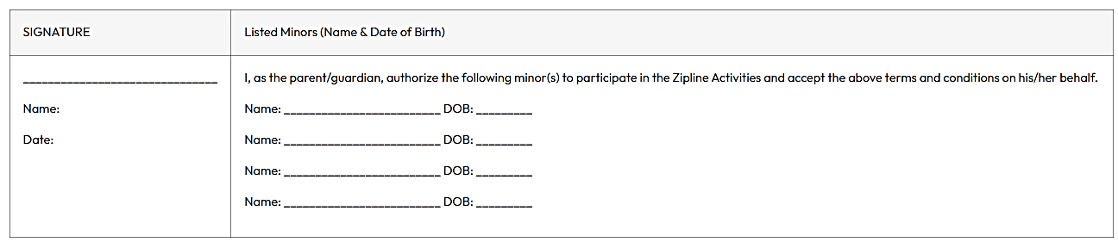I have fully understood and agreed to the above terms, and I accept full responsibility for the participant’s safety and conduct during the activities.